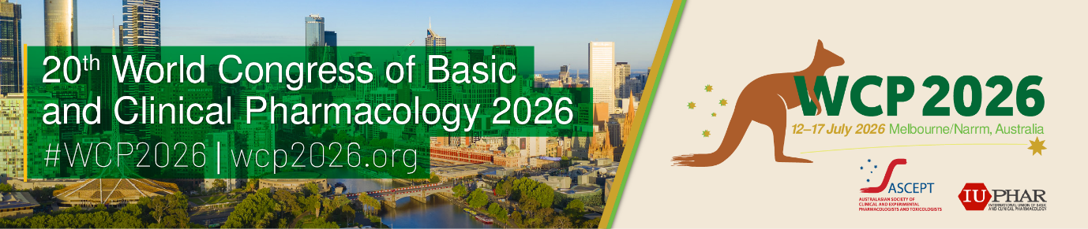

**Proposal for WCP2026 satellite meeting**

In addition to the WCP2026 program, satellite meetings may be held prior to commencement (e.g. Friday 10th and Saturday 11th July) or after the conclusion (from 4pm Friday 17th July) of the Congress.

A satellite meeting is a workshop or small, topically focused regional meeting held independently of WCP2026. It is defined based on its location, timing, and overlap with the intended audience for WCP2026. Satellite meetings should enhance WCP2026 and introduce or expand on the scientific content covered in the Congress. Satellite meetings may be open to anyone to attend and not restricted to registered congress delegates.

The WCP2026 Leadership Committee will review all satellite meeting applications. Only those considered to align with the congress will be approved and listed on the congress website.

Satellite meetings must be self-funded and independently managed, including but not limited to venue, audio visual, speakers, catering if required and delegate registration.

The congress organisers are not responsible for organising and promoting your satellite meeting to a broader audience. For maximum exposure of your satellite meeting to WCP2026 delegates, we encourage early application to align with abstract submission and early bird registration deadlines (14 Sep 2025 and 1 Apr 2026 respectively).

To apply, complete the details below and return via email to [wcp2026@expertevents.com.au](mailto:wcp2026@expertevents.com.au) for consideration by the WCP2026 Congress Leadership Group. If approved, you may be requested to provide additional information such as website URL, registration links etc.

|  |  |
| --- | --- |
| **Proposer’s details** | |
| **Name:** |  |
| **Affiliation:** |  |
| **Email:** |  |
| **Phone:** |  |

|  |  |
| --- | --- |
| **Satellite meeting details** | |
| **Proposed title:** |  |
| **Venue:** |  |
| **Short descriptive summary (<250 words)** |  |
| **Start time:** |  |
| **Finish time:** |  |
| **Registration fee:** |  |